
Tribhuvan University
Faculty of Humanities and Social Science
Bachelors in Computer Sciences

Project Proposal
On
“CanteenMate”
(Canteen Management System)

Submitted to
Department of Computer Application
Everest Innovative College

In partial fulfillment of the requirements for the Bachelors in Computer Application

Submitted by
Dibisha Haleyo Joshi
BCA 6th sem
Reg. no.: 6-2-713-5-2021

January 2025

TABLE OF CONTENTS
LIST OF ABBREVIATIONS iii
LIST OF FIGURES iv
1. INTRODUCTION 1
2. PROBLEM STATEMENT 2
3. OBJECTIVE 3
4. SCOPE 3
5. METHODOLOGY 4
a) Requirement Identification 4
i. Study of existing system 4
ii. Literature Review 4
iii. Requirement Analysis 5
b) Feasibility Study 7
Technical Feasibility 7
Operational Feasibility 8
Economic Feasibility 8
c) High Level Design of System 9
i. Methodology to be used 9
ii. System Architecture 9
iii. System Flow Chart and Working Mechanism 10
iv. Description of Algorithm 12
6. GANTT CHART 13
7. EXPECTED OUTCOME 14
8. REFERENCES

LIST OF ABBREVIATIONS
Abbreviation/Acronym Description
CMS Canteen Management System
CSS Cascading Style Sheet
HTML Hypertext Markup Language
JS JavaScript
SQLite Structured Query Language (SQL) Lite

LIST OF FIGURES
5. 1: Use Case Diagram for CanteenMate 7
5. 2: Agile Methodology for CanteenMate 9
5. 3: Three-tier architecture 10
5. 4: System Flowchart for CanteenMate 11
6. 1: Gantt Chart for CanteenMate 13

INTRODUCTION
Canteens serve as essential food service providers in institutions, offices, and public places. They cater to a large number of people daily, offering meals and refreshments conveniently. However, managing a canteen efficiently is challenging task, especially when relying on manual operations. Issues such as slow order processing, inventory mismanagement, and lack of transparency in financial transactions create inefficiencies that impact customer satisfaction and business profitability.
CanteenMate is an automated canteen management system (CMS) designed to digitalize and streamline daily operations. It enables real-time order placement, cashless transactions, stock monitoring and automated reporting. This system aims to enhance customer experience by reducing wait times, minimizing errors in order fulfillment, and providing seamless payment options.
The growing reliance on digital solutions across various industries emphasizes the need for canteens to adopt technology- driven management approaches. CanteenMate provides a centralized digital platform to optimize workflow, ensure better financial tracking, and promote a user-friendly experience for both customers and administrators. The implementation of this system will significantly reduce operational delays, enhance productivity, and improve overall service quality.
CanteenMate provides a centralized digital platform that not only optimizes workflow and financial tracking but also promotes transparency, sustainability (through reduces paper usage), and accountability. By implementing this system, canteens can significantly reduce operational delays, enhance productivity, minimize food wastage, and improve overall service quality thereby aligning with modern expectations in institutional and corporate environments.

PROBLEM STATEMENT
The conventional canteen management process involves several inefficiencies that hinder smooth operations and customer satisfaction. The primary challenges faced by canteens include:
- Long Waiting Times: Customers experience delays due to slow manual order processing, leading to dissatisfaction and crowding, especially during peak hours.
- Order Inaccuracies: Paper-based order tracking is prone to errors, resulting in incorrect or misplaced orders.
- Inefficient Payment Handling: Manual cash transactions increase the risk of errors, theft and delays in payment processing.
- Lack of Data Analytics: Traditional record-keeping methods make it difficult to analyze customer preferences.
- No Pre-ordering Facility: Customers cannot place orders in advance, which leads to congestion at counters and increased waiting time. It also affects the kitchen staff’s ability to prepare food in a timely manner.
- Limited Transparency and Communication: Customer are not updated about their order status, leading to repeated follow-ups and confusion.
These challenges highlight the urgent need for a smart, automated canteen management system that can streamline operations and enhance user experience.

OBJECTIVE
The objective is to carry out this project with the quality requirements as mentioned below:
- To develop a smart canteen management system that streamlines digital food ordering, payments, and real-time tracking while enhancing user experience and administrative efficiency.
- To implement a collaborative filtering algorithm for personalized food recommendation and integrate a feedback system to boost user engagement and service quality.

METHODOLOGY

Requirement Identification

Study of existing system
Canteen management systems have been widely adopted in various institutions and organizations to streamline food ordering, billing, and inventory management. Numerous studies have examined the implementation and effectiveness of digital canteen management systems in improving operational efficiency and customer satisfaction. These systems provide a centralized platform for both customers and administrators to place, manage, and track food orders efficiently.
Some of the existing systems are:
- SmartCanteen: SmartCanteen is an automated canteen management system that integrates online food ordering, payment and inventory tracking. It offers a user-friendly platform for customers to place orders digitally while enabling administrators to manage food stock and transactions efficiently. The major advantage of SmartCanteen include seamless inventory control, digital ordering that enhances user experience, and reduced manual errors. However, the system may involve a higher initial setup cost due to its wide range of features, and it might not be flexible enough for smaller canteens with simpler needs. [1]
- eCanteen: eCanteen is an online canteen management platform designed to optimize food ordering processes in educational institutions and corporate offices. The system supports cashless transactions, automated order tracking, and real-time reporting to enhance efficiency. Its strengths lie in improving operational efficiency and hygiene by promoting contactless payments. Real-time reporting also helps institutions make informed decisions. On the downside, eCanteen relies heavily on consistent internet connectivity, and its web-focused approach might not be as mobile-friendly as some newer solutions. [2]
- FoodSwipe: FoodSwipe is a digital canteen management system that enables users to pre-order through a mobile app or website. It integrates with multiple payment gateways, provides real-time order status updates, and helps reduce food waste through better demand forecasting. The system’s ability to minimize wastage and provide transparency during order processing are significant advantages. However, its advances features may require some user training, and the efficiency of its demand forecasting depends heavily on accurate data inputs and usage patterns. [3]
- CanteenPro: CanteenPro is a cloud-based canteen management solution that automates food ordering, billing and delivery tracking. It features an intuitive dashboard for administrators to monitor sales, manage menu pricing, and analyze customer preferences. Its scalability and strong analytics make it a powerful choice for large-scale operations. Its dependency on a stable internet connection and potential ongoing costs for cloud services could be seen as drawbacks for smaller or budget-conscious institutions. [4]
- iCanteen: iCanteen is a mobile-first solution created for educational environments. It allows students to order food in advance, helps canteen staff prepare meals efficiently, and supports digital payments and analytics for administrators. The key advantage sof iCanteen are its simplicity, mobile-centric design, and suitability for school environments. However, its narrow focus on education limits its versatility, and it may not offer the depth of features needed for corporate or larger-scale food service operations. [5]

Literature Review
In recent years, the demand for digital canteen management solutions has increased significantly due to growing need for efficiency and convenience in food ordering and service management. Many institutions, such as schools, colleges, corporate offices, and hospitals, rely on canteen services to provide meals for students, employees and staff. However, traditional canteen operations are still largely manual, leading to inefficiencies, delays, and errors in order processing. [6]
The existing system is primarily non-digital, where canteen staff do not maintain ledger or registers. Instead, they simply take money from customers and provide food, without any structured record-keeping of transactions. Customers often need to wait in long queues to place orders and make payments, causing inconvenience. Additionally, there is no real-time tracking of order status, leading to communication gaps and service delays. Moreover, the absence of a digital canteen management system means there is no automated order processing, cashless transactions, making it difficult to monitor sales, and customer preferences efficiently. [7]
Some of the key challenges faced in manual canteen management include:
- Difficulty in managing historical transactions.
- High dependency on manual processes, leading to human errors.
- Inefficiencies in order processing causing longer waiting times for customers.
- Absence of a centralized system for tracking sales and customer preferences.
To overcome these challenges, canteens need to adopt a digital canteen management system that automated order processing and billing. Implementing an online ordering system, digital payment integration, and real-time notifications can improve service efficiency and customer satisfaction. Additionally, cloud-based solutions can enable better data management, allowing administrators to monitor and optimize operations effectively.

Requirement Analysis
Requirement analysis is a crucial phase in the development of the Canteen Management System (CanteenMate). It involves analyzing and understanding the collected requirements to identify the system’s functionalities, constraints, and scope. Here are the key aspects of the requirement analysis for this project:
Requirement Collection through Internet
Conduct extensive research on the internet to gather additional requirements and insights related to canteen management systems. Explore industry best practices, case studies, and customer feedback to identify common features and functionalities that should be considered in the system.
By conducting comprehensive requirement analysis through internet research, you will gather valuable insights to inform the development of CanteenMate. This analysis will help identify the specific requirements and functionalities that need to be incorporated into the new system to address the shortcomings of existing systems and meet the needs of users effectively.
Functional Requirements
The features to be included in this project are:
For Customers:
- The system should allow customers to place orders online by selecting items, specifying quantity, payment options and choosing pickup or delivery options.
- The system should send automated notifications for order confirmation, estimated delivery time, and order completion.
For Admin:
- The system should allow the admin to login and logout from the system.
- The system should allow the admin to manage orders and update the status of the order.

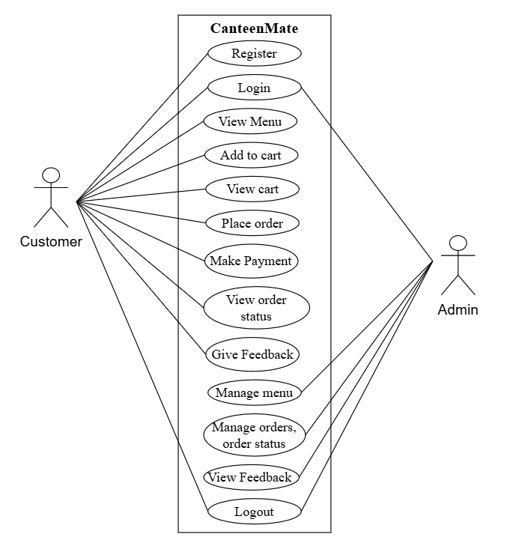
5. 1: Use Case Diagram for CanteenMate
Non-Functional Requirements
Availability: The system will be developed as a web application and can be used online for 24 hours.
Security: The system will be secure and data won’t be shared to third party entities. Only authorized entities have access to the data.
Performance: The system will be designed for smooth performance with optimization.
Reliability: The system will be reliable and gives the same result irrespective of the user if same operations are done.

Feasibility Study

Technical Feasibility
The proposed system CMS is technically feasible as it uses open- source, lightweight, and widely supported tools. The front end will be developed using HTML, CSS, Bootstrap, JavaScript, and Jinja2 for dynamic templates. Python and Flask will be used for the backend, with SQLite and SQLAlchemy for database management. A Conda environment will ensure smooth package and dependency management. Development tools like VS Code, Chrome, Draw.io, and Canva will support coding, testing, and designing. Basic hardware like a laptop, keyboard, and mouse is sufficient, making the system cost-effective and easy to implement.

Operational Feasibility
This system will include all the requirements required for the canteen management system and this system will be completely operational and can be successfully implemented and administration will feel easy to use this system as it will be user-friendly.

Economic Feasibility
The system is economically feasible as it is academic project. All the tools and resources required are either open source or free. After the completion of the system, there is no need to deploy any new hardware and software as the required software and hardware. The existing resource of the system can be used.

High Level Design of System

Methodology to be used
I am going to use Agile methodology while building the website. This project benefits from iterative development, continuous feedback, and adaptability to changing requirements, making Agile a suitable choice.
Agile is a software development methodology that emphasized flexibility, collaboration, and customer feedback. It breaks the project into small, manageable increments called sprints, allowing teams to deliver functional components regularly. Agile promotes adaptive planning, evolutionary development, early delivery, and continuous improvement throughout the development process.
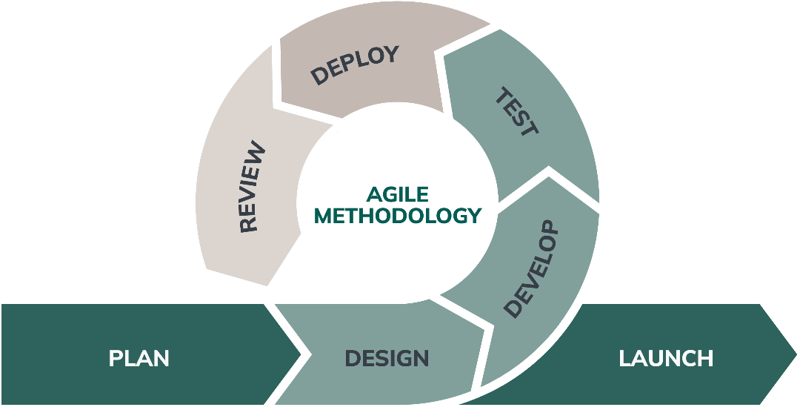
5. 2: Agile Methodology for CanteenMate [8]
Following are the reasons behind using Agile methodology for development:
  - Agile adapts to changing requirements throughout the project.
  - Continuous feedback ensures the product meets user needs.
  - Risks are addressed early through constant iterations.
  - Regular communication helps identify and solve issues quickly.

System Architecture
The proposed system is a 3-tier web-based system meaning a Client/Server Architecture in which the user interface, functional process logic, computer data storage, and the data access are developed and maintained as independent modules, most often in different platforms.
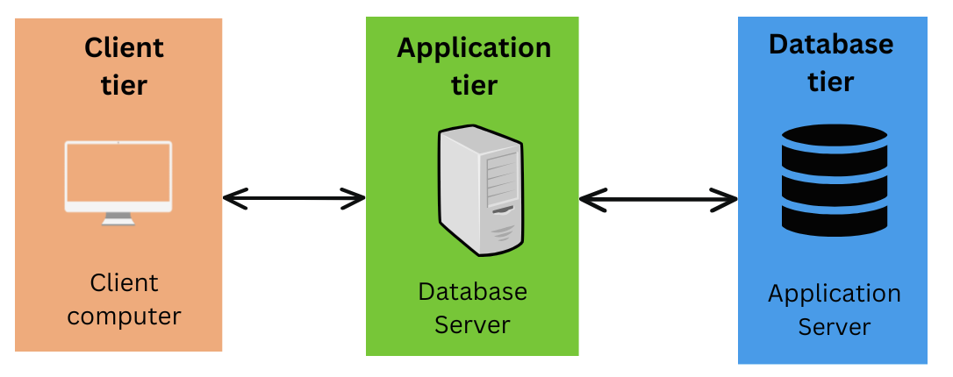
5. 3: Three-tier architecture
- Client layer: It is also called as Presentation layer which contains user interface part of application. This layer communicates with other through Application Program Interface calls.
- Application layer: In this layer all business logic written like validation of data, calculations, data insertion etc. This acts as an interface between user tier and database tier for faster communication.
- Database layer: Database layer helps to connect with database and to perform insert, update, delete, get data from the database based on user input data. These data are kept independent of application layer.
Following are the reasons behind choosing three tier-architecture:
  - It makes the logical separation among three different layers.
  - It makes the maintenance process easier.
  - It makes us easier to update one tier without involving other.

System Flow Chart and Working Mechanism
The working mechanism of the system is explained below with the help of system flow chart.
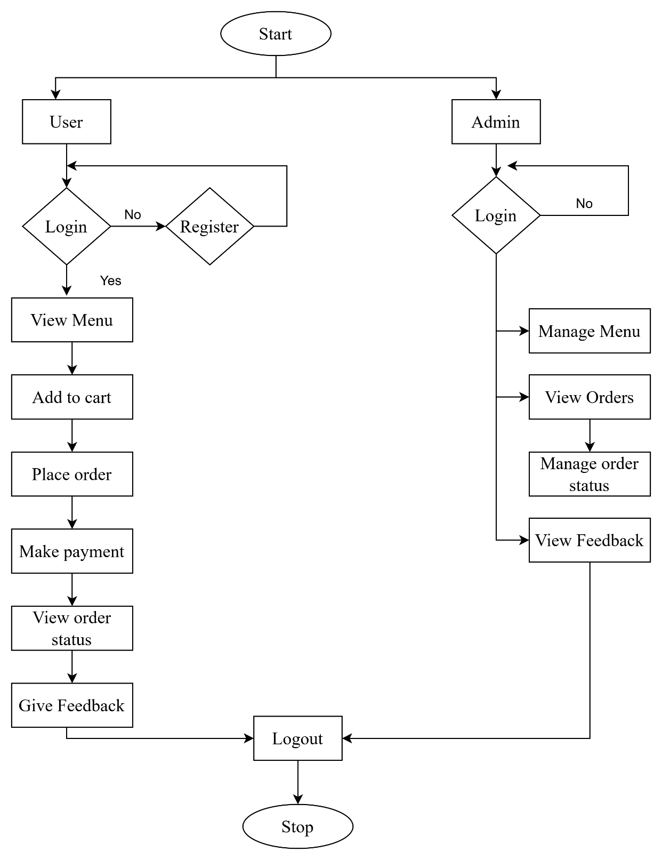
5. 4: System Flowchart for CanteenMate

Description of Algorithm
Collaborative Filtering: Collaborative filtering is a recommendation technique used in systems like CanteenMate to suggest food items to users based on the preferences of other users with similar tastes. Instead of relying on food item characteristics, it uses past user interactions. For instance, if a user has rated items like burgers and momos, collaborative filtering can predict how much they might like chowmein by analyzing how similar users liked that item. There are two main types: user-based collaborative filtering, which recommends items liked by similar users, and item-based filtering, which recommends items similar to what the user already like. In user-based collaborative filtering, similarity between user is calculated using cosine similarity given by formula:
Similarity_{A,B} = $\frac{A.B}{||A|| ×||B||}$
where A and B are rating vectors of two users. Once the similarities are calculated, the system predicts the rating for an unrated item using a weighted sum of ratings from similar users, as given by the prediction formula:
$$\hat{r_{A,i}}=\frac{\sum_{u∈N}{\text{sim}\left(A,u\right)}⋅r_{u,i}}{\sum_{u∈N}{\left|\text{sim}\left(A,u\right)\right|}}$$
Here, $\hat{r_{A,i}}$ is the predicted rating of user A for item I, sim(A, u) is the similarity between user A and user u, and $r_{u,i}$ is the rating user u gave to item i. This approach allows CanteenMate to personalize suggestions like recommending chowmein to a user who hasn’t tried it but may like it based on similar users’ preferences. [9]
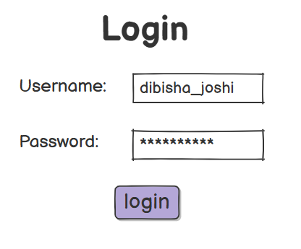
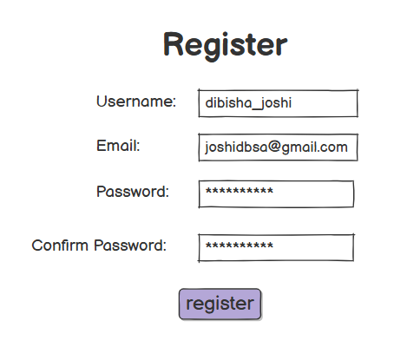
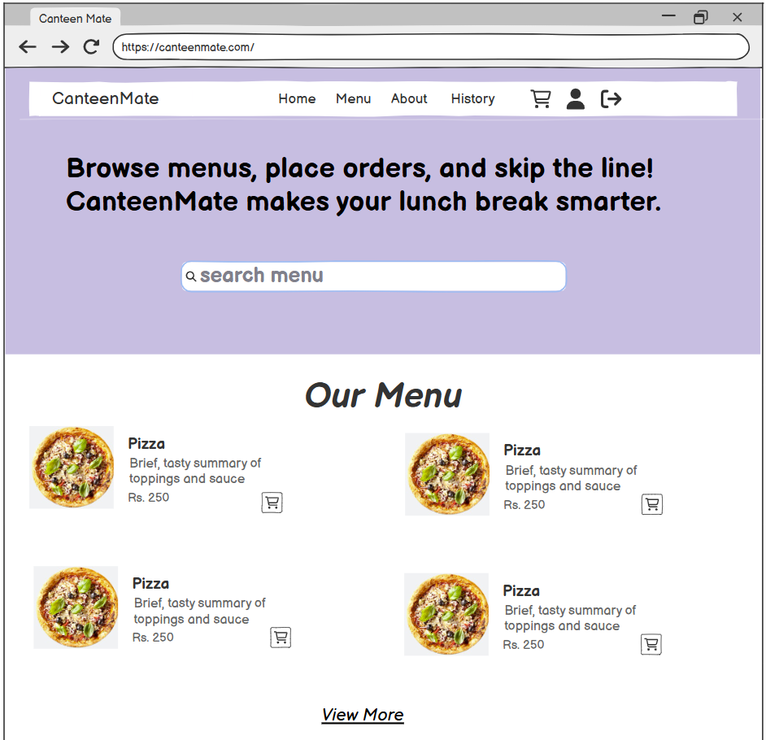
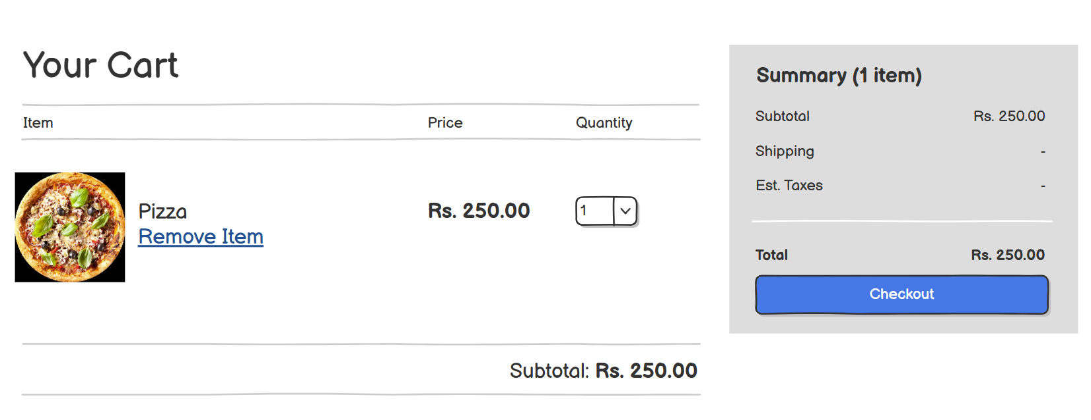
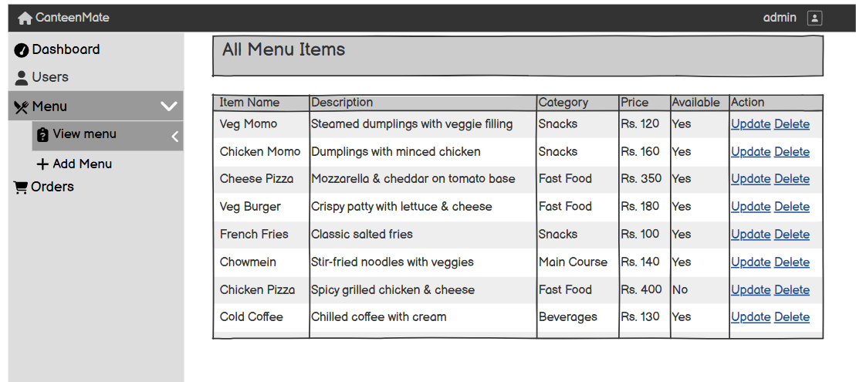
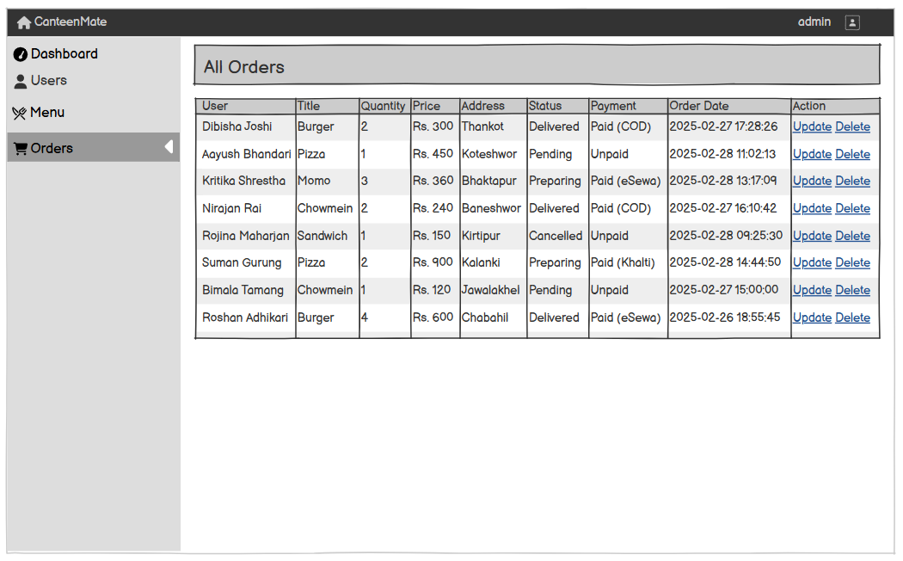

GANTT CHART
Gantt chart is a popular tool in project management which is useful for showing activities against the time. Each activity is represented by a bar. The position and length of the bar shows the start date, duration and end date of the activity.

6. 1: Gantt Chart for CanteenMate

EXPECTED OUTCOME
The CanteenMate aims to deliver a range of outcomes that will significantly enhance the efficiency, accuracy, and overall user experience in managing canteen operations. The system will automate core processes such as fool ordering, menu management, and reviews. This automation will minimize manual work, reduce errors, and speed up service delivery, resulting in smoother and more organized operations for canteen staff.
One of the primary expected outcomes is the digitalization of food ordering and payment, allowing customers to browse menus, place orders, and make payments through a user-friendly web or mobile interface. This will reduce long queues, waiting times, and order miscommunication, ultimately improving customer satisfaction. Additionally, customers will receive real-time updates on order status and estimated preparation or deliver time, enhancing transparency and convenience. The system will also introduce personalized food recommendations using collaborative filtering algorithms, which will suggest dishes based on past preferences and popular items. This will help increase customer engagement, promote frequently ordered items, and drive sales.
Overall, the system is expected to modernize the entire canteen ecosystem, enhance customer engagement, increase profitability, and contribute to sustainable and environmentally friendly operations.

REFERENCES

[1] | "SmartCanteen – A Cloud-Based Canteen Management System," [Online]. Available: https://app.smartcanteen.ae/.
[2] | "eCanteen Digital Food Ordering System," [Online]. Available: https://www.ecanteen.com.au/.
[3] | "FoodSwipe: Contactless Ordering and Payment System," [Online].
[4] | "CanteenPro: Web-Based Canteen Management Solution," [Online]. Available: https://canteenpro.com/.
[5] | "iCanteen: Canteen Management System," [Online]. Available: https://icanteen.co.uk/.
[6] | "Role of the Canteen and/or Other Food Service, Victorian Department of Education and Training, SchoolsVic.," [Online]. Available: https://www2.education.vic.gov.au/pal/canteens-and-healthy-eating/guidance/role-canteen-and/or-other-food-service.
[7] | "5 Challenges Schools Face with Canteen Operations and How to Solve Them, INLOGIC IT Solutions.," [Online]. Available: https://inlogic.ae/blog/5-challenges-schools-face-with-canteen-operations-and-how-to-solve-them/.
[8] | "Agile software development, nexapp," [Online]. Available: https://www.nexapp.ca/en/blog/agile-software-development. [Accessed Jan 2025].
[9] | Ricci, Recommender Systems Handbook, 2015.

